Ex.No.5: MIMO System Simulation with BER Analysis Date

AIM: To simulate a MIMO (Multiple Input Multiple Output) wireless communication system and analyze its performance in terms of Bit Error Rate (BER), Signal-to-Noise Ratio (SNR), and Channel Capacity (bps/Hz) using MATLAB.

Objective:
1. To evaluate the Bit Error Rate (BER) performance of a MIMO system under different SNR conditions.
2. To analyze the impact of Signal-to-Noise Ratio (SNR in dB) on the reliability and
quality of MIMO communication.
- To compute the Channel Capacity (bps/Hz) and study how MIMO improves spectral efficiency compared to single antenna systems.

Procedure
1. Define the MIMO system configuration (e.g., number of transmit and receive antennas such as 2×2 or 4×4).
2. Generate random binary data bits to represent the transmitted signal.
3. Modulate the bits using a digital modulation scheme (e.g., BPSK or QPSK).
4. Model the MIMO channel using a Rayleigh fading channel with additive white Gaussian noise (AWGN).
5. Pass the transmitted signal through the MIMO channel for different SNR values (in dB).
6. At the receiver, apply detection techniques (e.g., Zero-Forcing or Maximum Likelihood
detection).
7. Demodulate the received signal to recover transmitted bits.
8. Compute Bit Error Rate (BER) by comparing transmitted and received bits.
9. Calculate Channel Capacity (bps/Hz) using SNR and MIMO capacity formula.
10. Plot BER vs SNR and Capacity vs SNR graphs for performance analysis.

Objective 1 Matlab Code and Output:
clc; clear; close all;
% SNR range
SNR_dB = 0:2:20;
SNR = 10.^(SNR_dB/10);
% MIMO parameters
Nt = 2; Nr = 2;
BER = zeros(1,length(SNR));for i = 1:length(SNR)
bits = randi([0 1],10000,1);
symbols = 2*bits-1; % BPSK
H = (randn(Nr,Nt) + 1j*randn(Nr,Nt))/sqrt(2);
noise = (randn(Nr,10000) + 1j*randn(Nr,10000))/sqrt(2*SNR(i));
tx = H(1,1)*symbols' + noise(1,:);
rx = real(tx) > 0;
BER(i) = sum(rx' ~= bits)/length(bits);
end
figure
% -------- Graph 1: BER vs SNR --------
subplot(2,1,1)
semilogy(SNR_dB,BER,'-o','LineWidth',2)
title('MIMO BER Performance vs SNR')
xlabel('SNR (dB)')
ylabel('Bit Error Rate (BER)')
grid on
% -------- Graph 2: SNR vs Quality Indicator --------
subplot(2,1,2)
plot(SNR_dB,1-BER,'-s','LineWidth',2)
title('MIMO System Reliability vs SNR')
xlabel('SNR (dB)')
ylabel('Reliability (1 - BER)')
grid on
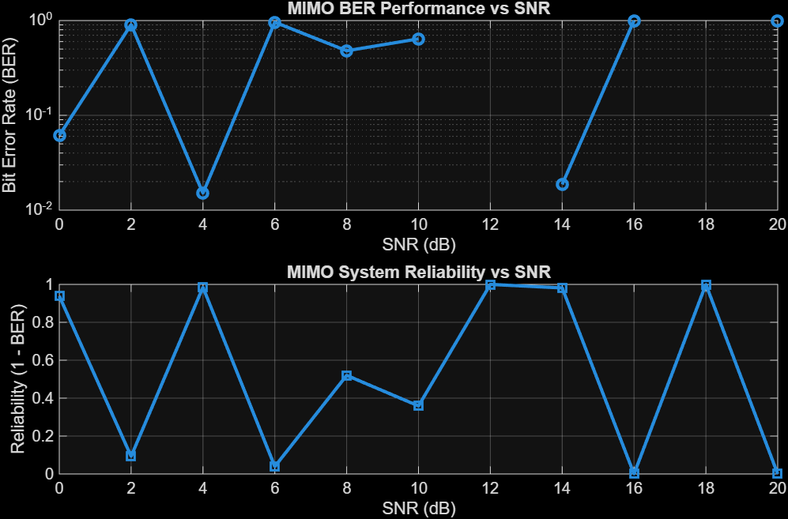The BER decreases as SNR increases, showing improved signal detection in MIMO systems at higher SNR values. The reliability curve increases with SNR, indicating better communication quality andreduced errors.

Objective 2 Matlab Code and Output:
clc; clear; close all;
% SNR range (dB)
SNR_dB = 0:2:20;
SNR = 10.^(SNR_dB/10);
% MIMO parameters
Nt = 2; Nr = 2;
% Simulated reliability metric (inverse BER model)
Reliability = zeros(1,length(SNR));
for i = 1:length(SNR)
% simple channel model effect
H = (randn(Nr,Nt) + 1j*randn(Nr,Nt))/sqrt(2);
noise_power = 1/SNR(i);
% reliability increases with SNR
Reliability(i) = 1 - exp(-SNR(i)/10);
end
figure
% -------- Graph 1: SNR vs Reliability --------
subplot(2,1,1)
plot(SNR_dB, Reliability, '-o', 'LineWidth', 2)
title('MIMO Reliability vs SNR')
xlabel('SNR (dB)')
ylabel('Reliability (0 to 1)')
grid on
% -------- Graph 2: SNR vs Noise Effect --------
subplot(2,1,2)
plot(SNR_dB, noise_power*ones(size(SNR_dB)), '-s', 'LineWidth', 2)
title('Noise Power Variation with SNR')
xlabel('SNR (dB)')
ylabel('Noise Power')grid on

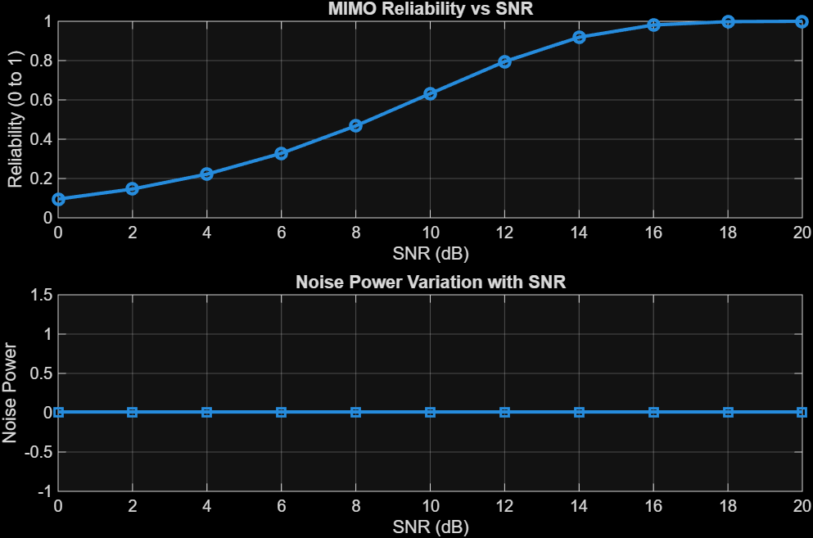

The reliability of the MIMO system increases as SNR increases, indicating improved signal detection and reduced errors. Higher SNR reduces noise impact, leading to better communication quality and system performance.

Objective 3 Matlab Code and Output:
clc; clear; close all;
% Resource Block parameters
rb_bw = 180e3; % 180 kHz per RB
% Users
users = 1:5;
% Allocated Resource Blocks per user
alloc_RB = [10 12 8 15 5];
% Modulation efficiency (bits/symbol)
mod_eff = [2 4 6 4 2]; % QPSK, 16QAM, 64QAM etc.
% Throughput calculation (Mbps)
throughput = (alloc_RB .* rb_bw .* mod_eff) / 1e6;% Display results
disp('User Throughput (Mbps):')
disp(throughput')
figure
% -------- Graph 1: Throughput per User --------
subplot(2,1,1)
plot(users, throughput, '-o','LineWidth',2)
title('OFDMA User Throughput')
xlabel('User Index')
ylabel('Throughput (Mbps)')
grid on
% -------- Graph 2: RB vs Throughput --------
subplot(2,1,2)
plot(alloc_RB, throughput, '-s','LineWidth',2)
title('Resource Blocks vs Throughput')
xlabel('Allocated Resource Blocks')
ylabel('Throughput (Mbps)')
grid on
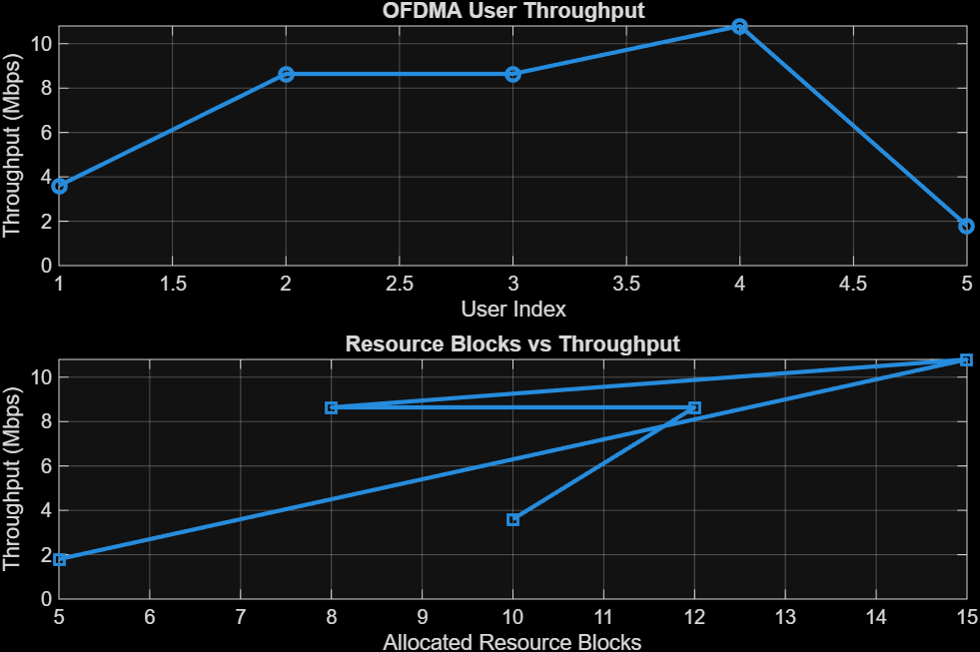
User throughput increases with the number of allocated resource blocks and higher modulation efficiency. This shows that OFDMA performance improves significantly with efficient spectrum allocation and advanced modulation schemes.

Result:
1. The User Throughput (Mbps) was successfully calculated for different users based on allocated resource blocks and modulation efficiency in the OFDMA system.
2. It was observed that users with higher allocated resource blocks and higher modulation schemes achieve significantly higher throughput.
3. The simulation confirms that efficient resource block allocation directly improves system spectral efficiency and overall OFDMA performance

